**The Fortifying Power of Data Science in Cybersecurity**

**Introduction**

In today's digital age, organizations rely heavily on data, making it a prime target for cybercriminals. Traditional security measures often struggle to keep pace with increasingly sophisticated threats. This is where data science emerges as a powerful weapon. Data science empowers security professionals to analyse vast amounts of data, identify hidden patterns, and predict potential attacks. This report explores the intersection of data science and cybersecurity, highlighting how data analytics fortifies defences and safeguards valuable information assets.

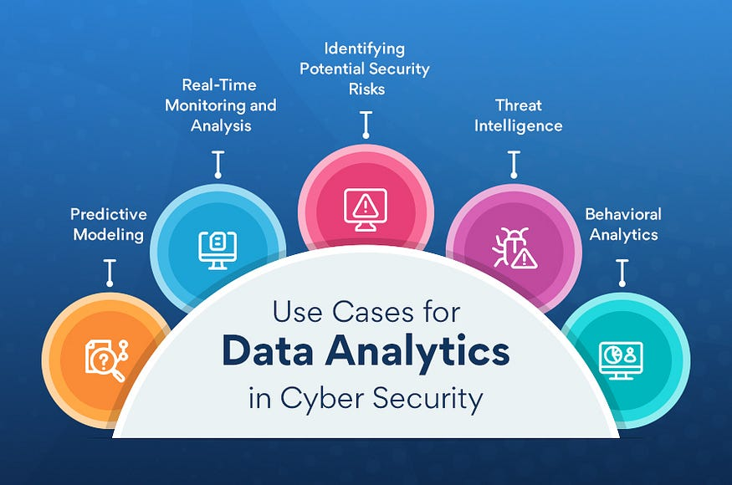

**Data Science Applications in Cybersecurity**

Data science offers a multifaceted approach to cybersecurity, encompassing various applications:

* **Threat Detection:** By analysing network traffic logs, system events, and user activity, data science helps identify malicious activity. Machine learning algorithms can detect subtle indicators of compromise (IOCs) that traditional security methods might miss.
* **Anomaly Detection:** Data science excels at identifying anomalies – deviations from normal user behaviour or system activity. These anomalies can be indicative of ongoing attacks or potential security breaches.
* **Predictive Analytics:** By analysing historical data on past attacks and vulnerabilities exploited, data science can predict future attack patterns. This enables proactive security measures, such as patching vulnerabilities and deploying advanced security controls.

**Big Data Analytics in Cybersecurity**

The vast volume of security data generated by organizations requires advanced analytics capabilities. Big data analytics empowers security teams to:

* **Handle Large Volumes of Data:** Security teams can leverage big data platforms to process and analyse massive datasets efficiently, extracting valuable insights for threat detection and prevention.
* **Real-time Monitoring:** Big data allows for real-time monitoring of security data streams, enabling immediate identification and response to ongoing cyberattacks. This minimizes potential damage and disruption.
* **Utilizing Big Data Technologies:** Big data technologies like Hadoop and Spark enable the distributed processing and analysis of large datasets, facilitating faster and more comprehensive threat detection.

**Machine Learning for Cyber Threat Intelligence**

Machine learning plays a crucial role in extracting actionable intelligence from security data. Key applications include:

* **Natural Language Processing (NLP):** NLP allows machines to understand and analyse text data from security sources like threat reports and social media feeds. This empowers security teams to stay updated on emerging threats and attack vectors.
* **Supervised and Unsupervised Learning Techniques:** Supervised machine learning algorithms can be trained to identify malicious activity based on labelled datasets of past attacks. Unsupervised learning algorithms can detect anomalies and unusual patterns in security data, potentially revealing new threats.
* **Automated Threat Hunting:** Machine learning can automate threat hunting, freeing up security personnel for strategic tasks. By continuously analysing data, ML algorithms can identify suspicious activity that might go unnoticed with manual efforts.

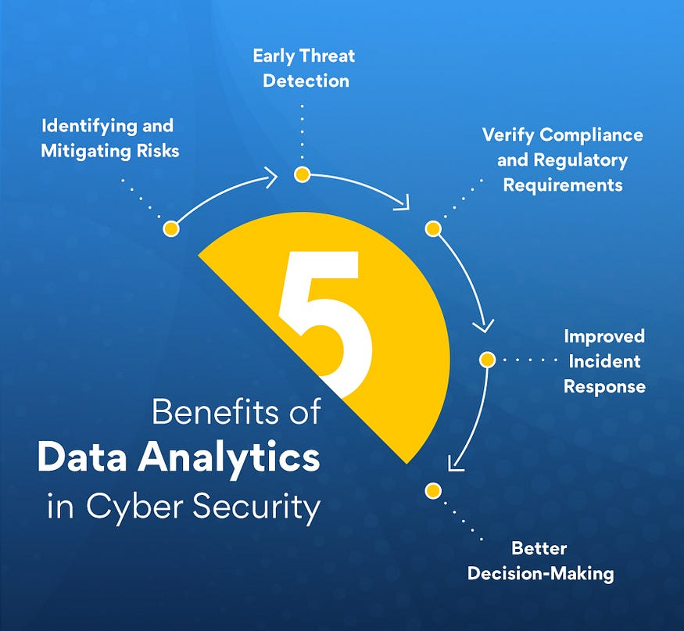

**Cybersecurity Challenges Addressed by Data Science**

Data science offers solutions to some of the most pressing cybersecurity challenges:

* **Advanced Persistent Threats (APTs):** APTs are sophisticated cyberattacks designed for long-term infiltration. Data science can help detect subtle anomalies in network traffic and user behaviour, potentially revealing ongoing APT activity.
* **Insider Threats:** Data science can be used to analyse user activity patterns and identify deviations that might indicate malicious insider activity, such as unauthorized access attempts or data exfiltration.
* **Vulnerability Management:** Data science can analyse security data to identify vulnerable systems and prioritize patching efforts based on potential risk factors. This enables organizations to focus their resources on addressing the most critical vulnerabilities first.

**Data Privacy and Ethical Considerations**

Balancing data security with data privacy is paramount. When implementing data science for cybersecurity, organizations must consider:

* **Balancing Data Access and Privacy:** Striking a balance between granting security teams access to the data they need for analysis and protecting user privacy is crucial. This might involve anonymizing data before analysis or obtaining explicit user consent for data collection and use in security applications.
* **Responsible Data Use:** Organizations must ensure that data collected for security purposes is used responsibly and ethically. Data should only be used for its intended purpose and secure disposal practices should be implemented.
* **Compliance with Regulations:** Data privacy regulations like GDPR and CCPA must be considered when collecting and analysing data for security purposes.

**Future Trends and Innovations**

The intersection of data science and cybersecurity is continuously evolving, with exciting trends shaping the future landscape:

* **Evolution of AI-Powered Attacks and Defences:** As AI advances, cybercriminals are developing AI-powered attack tools. Conversely, AI can be used to develop advanced threat detection and automated response systems.
* **Integration of AI/ML with Cybersecurity Tools:** Security tools are increasingly incorporating AI and machine learning capabilities, offering more sophisticated threat detection and prevention functionalities.
* **Role of Data Science in Shaping Cybersecurity:** Data science will continue to play a pivotal role in shaping the future of cybersecurity, driving innovation in threat detection, prediction, and automated response mechanisms.

**Case Studies and Examples**

Real-world examples showcase the effectiveness of data science in cybersecurity:

* **Financial Institution Uses Machine Learning to Detect Fraudulent Transactions:** A large financial institution implemented a machine learning model to analyse customer transaction data. The model was trained to identify anomalies and patterns indicative of fraudulent activity, such as unusual purchase locations, high-value transactions outside of typical spending habits, or attempts to access accounts from unfamiliar devices. This system significantly reduced fraudulent transactions and protected customer accounts.
* **Retail Giant Uses Big Data Analytics to Prevent Cyberattacks:** A major retail chain deployed a big data analytics platform to monitor network traffic in real-time. The platform analyzed vast amounts of data to identify suspicious activity, such as unauthorized access attempts or malware infections. By detecting these threats early, the company was able to prevent major cyberattacks and safeguard customer data.

**Conclusion**

Data science has emerged as a transformative force in cybersecurity. By leveraging data analytics, organizations can gain a deeper understanding of their security posture, identify potential threats, and proactively address vulnerabilities. Machine learning, big data analytics, and other data science techniques empower security teams to move beyond reactive measures and adopt a more proactive approach to cybersecurity. As cyber threats continue to evolve, data science will play a crucial role in safeguarding our digital world.

**References**

* Gartner: <https://www.gartner.com/en/topics/cybersecurity>
* IBM Security: <https://securityintelligence.com/about-us/>
* Dark Reading: <https://www.darkreading.com/latest-news>
* MIT Technology Review: <https://www.technologyreview.com/>